**Thermodynamics computer exercise 3**

**Lunar soil reduction by carbon and hydrogen**

Mikko Karkkainen 11740378

The purpose of this exercise was to simulate the reduction of metals in the lunar soil using solid carbon and hydrogen gas using the HSC software.

The composition of the lunar soil is given in table 1.

Table 1. Composition of lunar soil (100kg)

|  |  |  |
| --- | --- | --- |
| **Phases** | **Amount (Wt%)** | **Amount (kmol)** |
| SiO2 | 47.71 | 0.794 |
| TiO2 | 1.59 | 0.02 |
| Al2O3 | 15.02 | 0.147 |
| Fe2O3 | 3.44 | 0.022 |
| FeO | 7.35 | 0.102 |
| MgO | 9.01 | 0.224 |
| CaO | 10.42 | 0.186 |
| Na2O | 2.7 | 0.044 |
| K2O | 0.82 | 0.009 |
| MnO | 0.18 | 0.003 |
| P2O5 | 0.55 | 0.005 |

# Hydrogen reduction

## Effect of amount of hydrogen

First, reduction with hydrogen was modelled. The composition of the slag, silicates, alloys, and reaction gasses in the end product was calculated with hydrogen input values between 1 and 8 kmol at 1900 °C The results are shown in figures 1-4. Figure 2 shows that adequate reduction was achieved with 4 kmol of hydrogen. Increasing hydrogen content shows diminishing returns, because at higher amounts of hydrogen, more FeSi is formed.

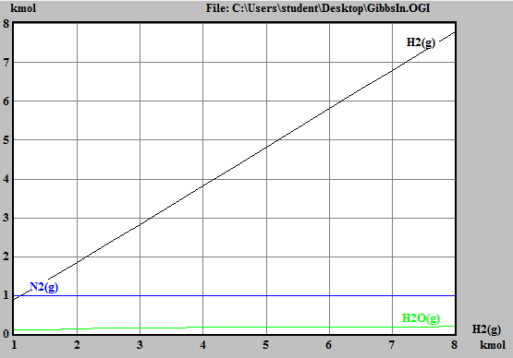

Fig. 1 Composition of reaction product gasses as function of hydrogen at 1900 °C

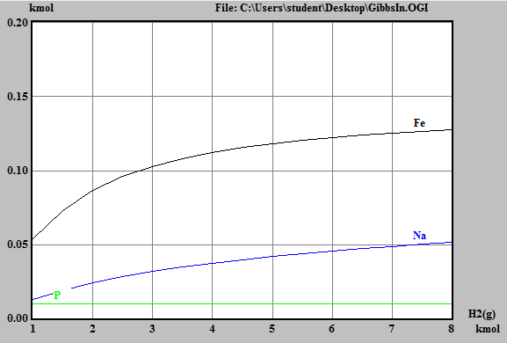

Fig. 2 Composition of reduction product alloy as function of hydrogen at 1900 °C

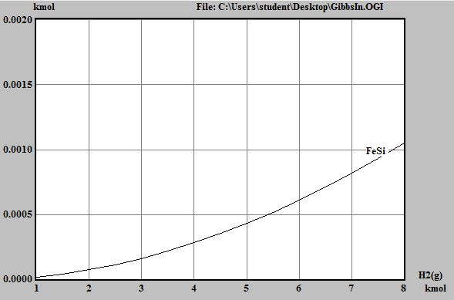

Fig. 3 Composition of reduction product silicates as function of hydrogen at 1900 °C

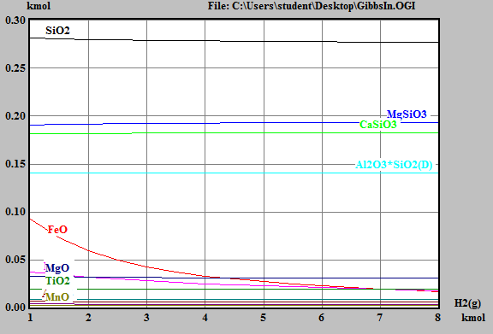

Fig. 4 Composition of reduction product slag as function of hydrogen at 1900 °C

## Effect of temperature

Next, the effect of process temperature on the hydrogen reduction process was examined. Figures 6 shows that increasing temperature above 1300 °C did not significantly affect the reduction of alloys other than Na. Therefore, the optimal reaction temperature can be taken as 1300 °C (the lowest value examined). Figure 7 shows that most of the iron in the hydrogen reduction process goes into the silicate phase as FeSi at higher temperatures. Figures 5 and 8 show that neither the product gasses nor the slag show major change with temperature.

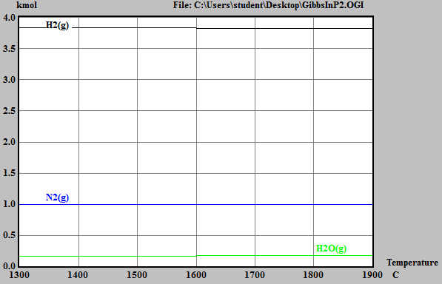

Fig. 5 Composition of reaction product gasses as function of temperature

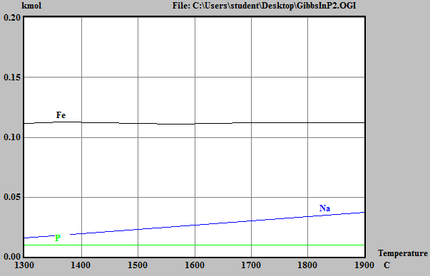

Fig. 6 Composition of alloy products as function of temperature

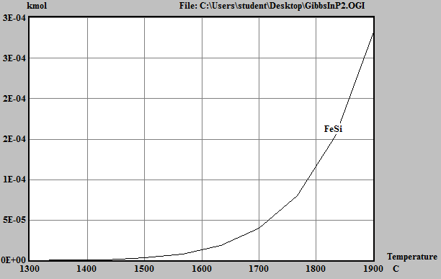

Fig. 7 Composition of silicates as function of temperature

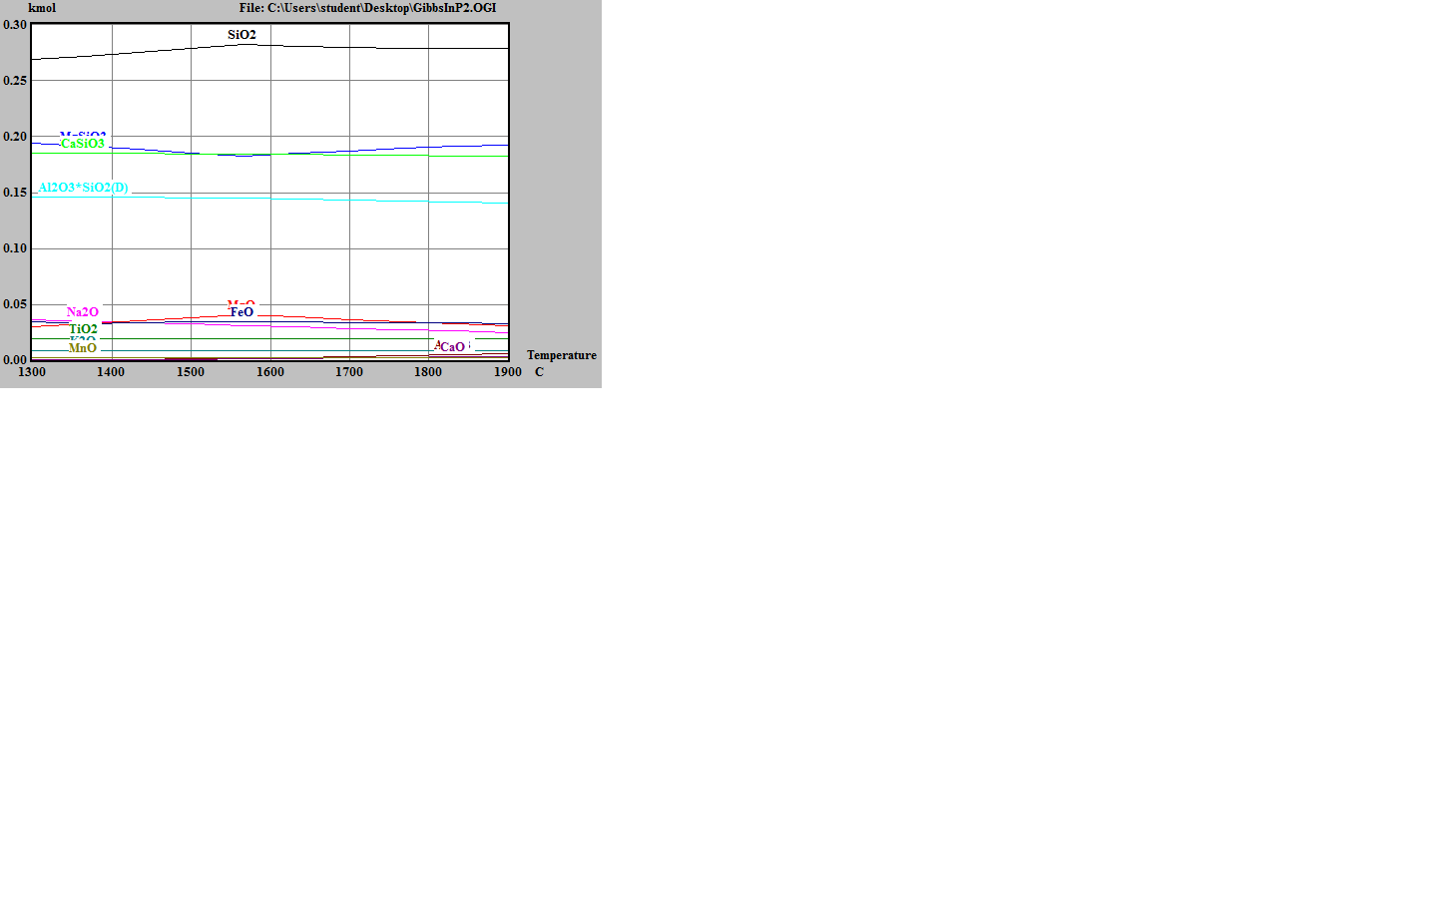

Fig. 8 Composition of slag as function of temperature

## 1.3 Efficiency of reduction

Table 2 shows the amount of reduced metals as a function of temperature. In table 3, the efficiency of reduction for the hydrogen process was calculated based on table 1 and 2 for the chosen optimum temperature 1300 °C. Iron was reduced at 76 % efficiency, sodium at 18 % efficiency and phosphorus at 100% efficiency. Si, Mg and Al were not reduced.

Table 2. quantity of reduced alloy in hydrogen process as function of temperature

|  |  |  |  |  |
| --- | --- | --- | --- | --- |
|  | C | 1300.00 | 1700.00 | 1900.00 |
| Fe | mol | 111.384 | 111.874 | 112.334 |
| Na | mol | 15.806 | 30.402 | 37.583 |
| P | mol | 10.000 | 10.000 | 10.000 |
| Si | mol | 0.000 | 0.001 | 0.009 |
| Mg | mol | 0.000 | 0.000 | 0.000 |
| Al | mol | 0.000 | 0.000 | 0.000 |

Table 3. Efficiency of reduction

|  |  |  |  |
| --- | --- | --- | --- |
| Alloy | Amount in 100 kg soil (mol) | Amount reduced (mol) | Efficiency |
| Fe | 146 | 111.384 | 0.762904 |
| Na | 88 | 15.806 | 0.179614 |
| P | 10 | 10 | 1 |
| Si | 794 | 0 | 0 |
| Mg | 224 | 0 | 0 |
| Al | 294 | 0 | 0 |

# Carbon reduction process

## Effect of amount of carbon

Figures 9-12 show the effect of varying the amount of carbon used for the reduction process at 1900°C on the amount of products in the gas, alloy silicate and slag phases respectively. The figures show that 4 kmol of carbon was adequate for the reduction of most of the alloy. Interestingly, no iron was resumed, presumably because it became iron carbide in the process.

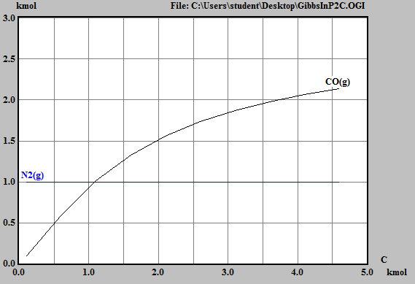

Fig. 9 Amount of product gasses as a function of the amount of carbon.

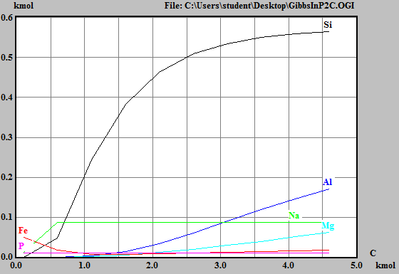

Fig. 10 Amount of product alloy as a function of amount of carbon.

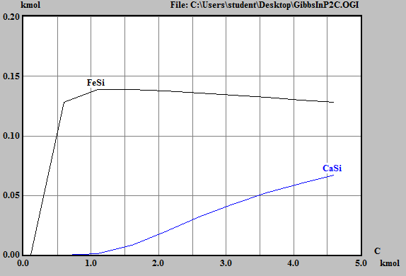

Fig. 11 Amount of product silicates as a function of amount of carbon



Fig. 12 Amount of product slag as a function of amount of carbon

## Effect of temperature

Figures 13-16 show the effect of temperature on the reaction products of the carbon reduction process. Figure 14 shows that it is difficult to choose an optimum temperature for the process. At 1300 °C, iron can be extracted, but at higher temperatures, it transforms into Fe-C. To significantly reduce silicon, a temperature of over 1700 °C is required. Furthermore, to reduce Al or Mg, the temperature should be above 1900°C. Therefore the choice of temperature depends on what reaction products are deemed most valuable.

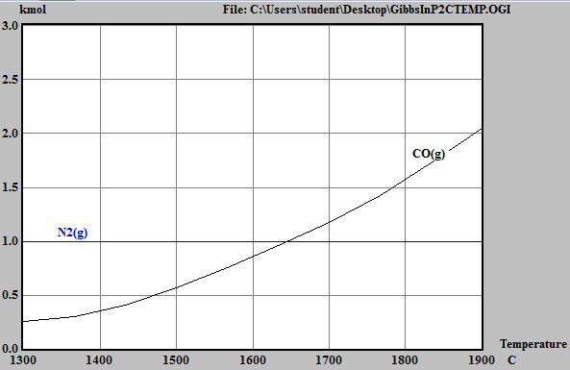

Fig. 13 Amount of process gasses as function of temperature

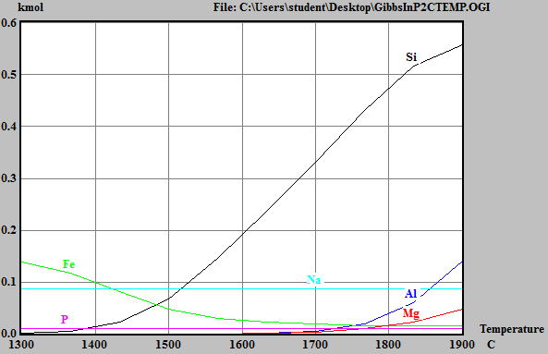

Fig. 14 Amount of alloy as function of temperature

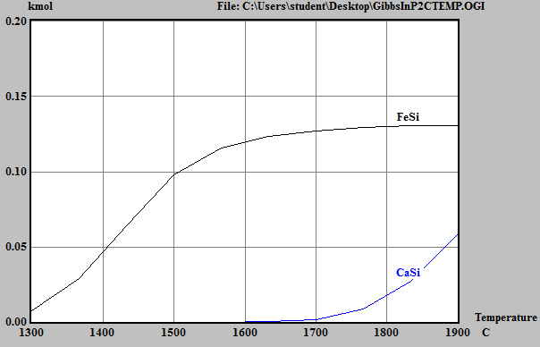

Fig. 15 Amount of silicates as function of temperature

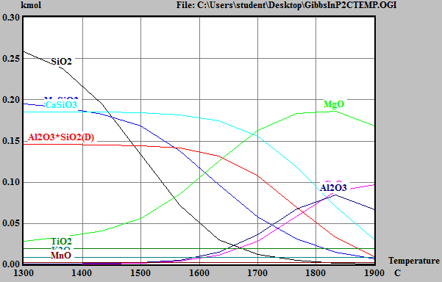

Fig. 16 Amount of slag as function of temperature

## Efficiency of reduction

Table 4 shows the amount of alloy materials reduced in the carbon reduction process as a function of temperature. We can see that Fe,P and Na can be reduced almost completely at 1300° C. However, if the goal is to reduce Si, Al or Mg, a higher temperature should be chosen. At 1900 °C 10 % Fe, 21% of Mg, 48 % Al and 70 % Si can be reduced, as seen in table 5.

For the reduction of Fe, P, and Na, 1300°C and 4kmol of C is close to optimal.

For the reduction of Mg, Al and Si, the efficiency can be improved by increasing the amount of carbon to more than 4kmol and increasing the reaction temperature to 1900°C (or even higher if possible).

Table 4. Amount of reduced alloy in the carbon process as a function of temperature

|  |  |  |  |  |
| --- | --- | --- | --- | --- |
| **T** | C | 1300.00 | 1700.00 | 1900.00 |
| Si | mol | 1.06 | 332.01 | 556.93 |
| Fe | mol | 138.03 | 19.05 | 15.50 |
| Al | mol | 0.00 | 4.90 | 141.17 |
| Na | mol | 87.99 | 88.00 | 88.00 |
| Mg | mol | 0.00 | 3.80 | 48.59 |
| P | mol | 10.00 | 10.00 | 10.00 |

Table 5. Efficiency of reduction at 1900 °C

|  |  |  |  |
| --- | --- | --- | --- |
| Alloy | Amount in 100 kg soil (mol) | Amount reduced (mol) | Efficiency |
| Fe | 146 | 15.50 | 0.106164384 |
| Na | 88 | 88.00 | 1 |
| P | 10 | 10 | 1 |
| Si | 794 | 556.93 | 0.701423174 |
| Mg | 224 | 48.59 | 0.216919643 |
| Al | 294 | 141.17 | 0.480170068 |